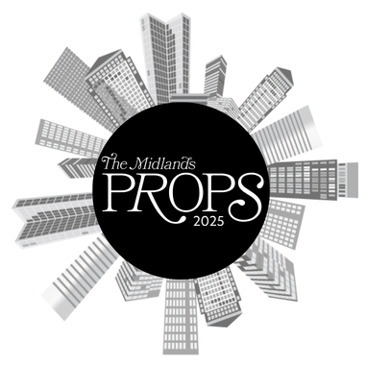

The Midlands Props Awards 2025
Nomination Form

Award Category: Building of the Year Award

This category aims to recognise an outstanding building constructed in the Midlands including residential, office, industrial, retail, leisure and/or community use.

Criteria:

Nominations may come from any developer, consultant or client team associated with the building design or construction.

Nominations are encouraged to evidence architectural flair, best-in-class design, social value, sustainability credentials and or positive impact upon the local community.

To be eligible, entries and evidence must relate to the year from 1st Jan 2024 to 31st Dec 2024.

Please submit this form and any supporting evidence to sally.richards@variety.org.uk.

Project Name:
Site Address:
Project Sector:
Project Description:
Date of Project Completion (DD/MM/YYYY)
Date of Project Occupation (DD/MM/YYYY)
Reason for nomination: (please include evidence with facts and figures including any social value, sustainability or community impacts).

Nominee Company Name:
Nominee Email Address:
Nominee Phone Number:
Project Construction Cost:
Project Contractor:
Project Design Consultants:
Project Client Name:
Anything else you would like to add
Nominator Contact Details (if different to nominee)
Please include name, Company name, contact number and email
Supporting Documents attached: | Yes/No

Images
Please include photographs as part of your submission. Maximum of 10 photographs,
Images should be a mixture of external and internal shots of the project. These images are used for judging purposes and should convey the way in which the project relates to its context. We advise both wide shots and close-ups and, if possible, show the building in use.
Drawings
It is helpful to include a location plan, site plan, ground floor plan, typical floor plan, and sections of the building.

