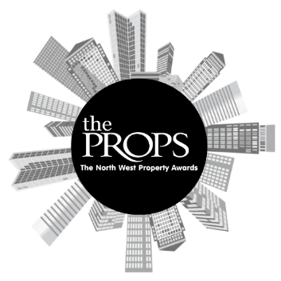

The North West Props Awards 2024
Nomination Form

Award Category: Agent of the Year Award
An award to recognise an agent or practice that stands out in having made a difference in the property market, regardless of their sector or specialism.

Criteria:
Open to agents or practices in the North West.
The award is not specific to any particular service area and is open to all that are relevant for commercial property, for example capital markets, leasing, occupational, valuation, management, consultancy, development etc.
Entries should relate to activity between 1st October 2023 and 30th September 2024.

Please submit this form and any supporting evidence to sally.richards@variety.org.uk.
Nominee (Person or Company):
Email Address:
Phone Number:
Reason for nomination:

Anything else you would like to add:

Nominator contact details (if different from above):

Supporting Documents attached:

