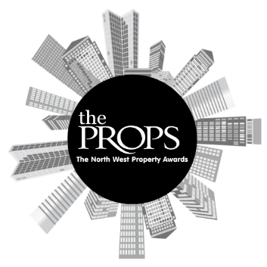

The North West Props Awards 2023
Nomination Form

Award Category: Property for Purpose
Rewarding a development project for its positive impact on its surrounding community, delivered with more than just profit in mind.
Criteria:
This category is open to all sectors working in the property sector across the North West. The submission needs to demonstrate that purpose was considered at least on par with financial returns, if not ahead of. Breadth and depth of community impact will also be considered. Please state who the project benefited, how much and what impact this project will have now and in the future.
The project must be able to demonstrate that it has raised the bar in terms of creating something other than for profit during the period 1st January 2023 - 31st December 2023.
Project Name:
Company Name:
Contact Name:
Contact Email Address:
Contact Phone Number:
Project stakeholders:
Overview of the Project:

Detail the positive impact that this project has had on the community?

Who will benefit from this project?

How will the positive impact continue in to the future?

Reason for nomination:

Anything else you would like to add
Nominator Contact details (if different then contact information above. Please include, Name, phone number and email)
Supporting Documents attached: | Yes/No

