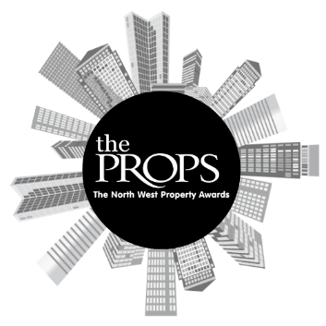

The North West Props Awards 2023
Nomination Form

Award Category: Sustainability Award
This award seeks to recognise a development project that demonstrates an outstanding commitment to sustainability. Nominations are sought for projects that prioritise environmental sustainability, at its core and beyond.
Criteria:
This award is open to all sectors of commercial property in the North West. Judges will be looking for a project with clear, quantitative examples of how environmental performance and/or sustainability has been prioritised to be at least on par with financial returns, if not ahead of. This should include measures being taken to reduce or mitigate upfront and whole life carbon, water use and management, operational waste, user health and wellbeing etc. Judges will be looking for measures implemented and their impact, not just future plans.
This project must be during the period from 1st January 2023 - 31st December 2023.
Nominee Project Name:
Nominee Contact Name:
Nominee Contact Email Address:
Nominee Contact Phone Number:
Overview of the Project:

Key project stakeholders:
What sustainability measures were implemented in this project?

How was substantiality prioritised in this project?

What are the ongoing and future plans for this project in terms of its environmental impact?
Reason for nomination and any other information:

Anything else you would like to add
Nominator Contact details (If different then nominee. Please include Name, phone number and email).
Supporting Documents attached: | Yes/No

