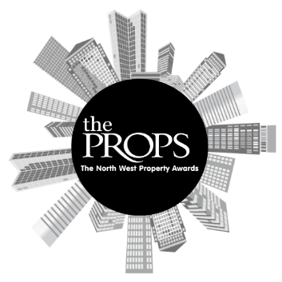

The North West Props Awards 2025
Nomination Form

Award Category: Sustainability Award
This award seeks to recognise a development project that demonstrates an outstanding commitment to sustainability. Nominations are sought for projects that prioritise environmental sustainability, at its core and beyond.
Criteria:
Open to all sectors of commercial property in the North West.
Judges are looking for a project with clear, quantitative examples of how environmental performance and/or sustainability has been prioritised to be at least on par with financial returns, if not ahead of.
Entries should relate to activity between 1st October 2024 and 30th September 2025.
Please submit this form and any supporting evidence to sally.richards@variety.org.uk.

Property / Project Name:
Project stakeholders (award nominees):
Contact Name:
Contact Email Address:
Contact Phone Number:
Overview of the Project:

Reason for nomination:

Anything else you would like to add:

Nominator contact details (if different from above):

Supporting Documents attached:

